Experiment 6: Naïve Bayes Algorithm

AIM
To implement the Naïve Bayes Classification Algorithm in Python and evaluate its performance using Confusion Matrix and Accuracy.
ALGORITHM
- Import the required libraries.
- Load the Iris dataset.
- Split the dataset into training and testing sets.
- Train the Naïve Bayes classifier using the training data.
- Predict the class labels for the test data.
- Compute the confusion matrix.
- Calculate the accuracy of the model.
- Display the confusion matrix and accuracy.
PROGRAM
from sklearn.datasets import load_iris
from sklearn.model_selection import train_test_split
from sklearn.naive_bayes import GaussianNB
from sklearn.metrics import confusion_matrix, accuracy_score

# Load Iris dataset
iris = load_iris()

X = iris.data
Y = iris.target

# Split dataset
X_train, X_test, Y_train, Y_test = train_test_split(
X, Y, test_size=0.3, random_state=42)

# Train Naive Bayes model
model = GaussianNB()
model.fit(X_train, Y_train)

# Prediction
pred = model.predict(X_test)

# Results
print("Confusion Matrix:")
print(confusion_matrix(Y_test, pred))

print("\nAccuracy:")
print(accuracy_score(Y_test, pred))

Sample Output
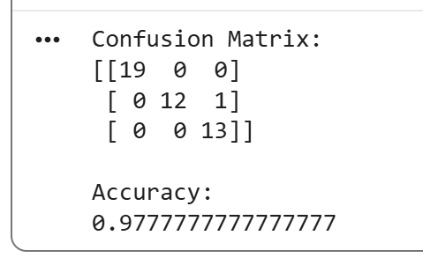

Experiment 7: Logistic Regression

AIM
To implement the Logistic Regression algorithm in Python for classification using the Iris dataset.
ALGORITHM
- Import the required libraries.
- Load the Iris dataset.
- Split the dataset into training and testing sets.
- Standardize the input features.
- Train the Logistic Regression model.
- Predict the test dataset.
- Calculate the confusion matrix and accuracy.
- Display the results.
PROGRAM
from sklearn.datasets import load_iris
from sklearn.model_selection import train_test_split
from sklearn.preprocessing import StandardScaler
from sklearn.linear_model import LogisticRegression
from sklearn.metrics import confusion_matrix, accuracy_score

# Load Iris dataset
iris = load_iris()

X = iris.data
Y = iris.target

# Split dataset
X_train, X_test, Y_train, Y_test = train_test_split(
X, Y, test_size=0.3, random_state=42)

# Feature Scaling
scaler = StandardScaler()
X_train = scaler.fit_transform(X_train)
X_test = scaler.transform(X_test)

# Logistic Regression Model
model = LogisticRegression(max_iter=200)

model.fit(X_train, Y_train)

# Prediction
pred = model.predict(X_test)

# Results
print("Confusion Matrix:")
print(confusion_matrix(Y_test, pred))

print("\nAccuracy:")
print(accuracy_score(Y_test, pred))

Sample Output




